# CS 255 System Design Document Template

This template lays out all the different sections that you need to complete for Project Two. Each section has guidance to prompt your thinking. You will need to continually reference the interview transcript as you work to make sure that you are addressing your client’s needs. There is no required length for the final document. Instead the goal is to complete each section based on what your client’s needs are. Remove this note when you are finished, and replace all bracketed text with the relevant information.

## UML Diagrams

### UML Use Case Diagram

### UML Activity Diagrams

**Login or Register.**

**Buy package.**

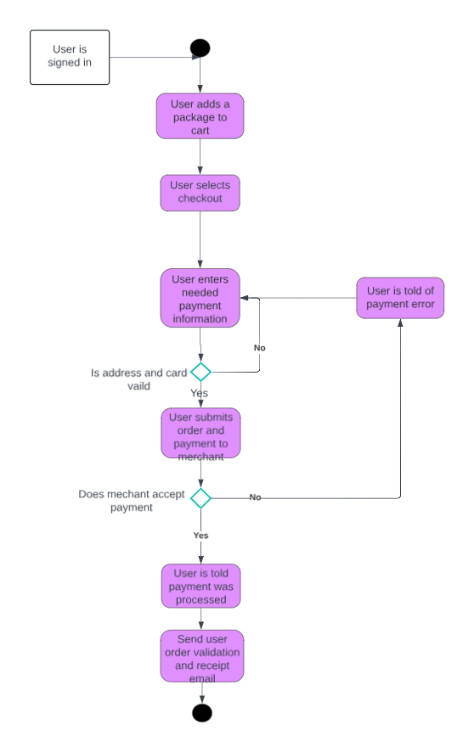

### UML Sequence Diagram

.**

### UML Class Diagram

**DriverPass Class Diagram.**

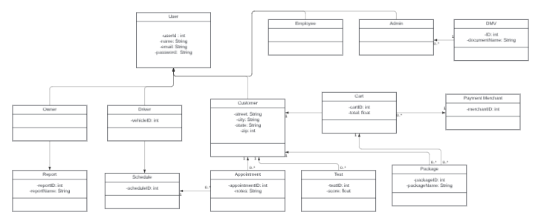

## Technical Requirements

* Users need a case sensitive password to access their account
  + If password is forgotten users can request to change their password
  + After a number of attempts at the password the account should lock to prevent a brute force hacking attempt.
* Use email verification during user setup for resetting password and to avoid bot accounts.
* Should use the HTTPS protocol for sending and receiving data.
* Users should be able to update their personal data
  + Employees will also be able to update users’ personal data
* Admin should have access to users’ personal data and will be able to create, manage, and disable or remove employees accounts.
* When web application and web database are updated the platform should not be affected by the updates allowing users to still use the program.
* The system should run on mobile and desktop browsers such as,
  + Microsoft Edge
  + Google Chrome
  + Safari
  + Bing
  + Firefox
  + And more
* The backend will require a:
* Database to hold users and system information
* And a web server to process request and to manage response
* Web-based cloud
* Users load times should be fast, average of 1-2 second.
* If the system takes over 3 seconds to load it should provide feedback
* The system should be updated whenever new guidelines from the DMV are posted or once a month.